עידו כץ
אמילי מיאסקובסקי
Project Detailed Design
1. System Architecture
The system is based on a Raspberry Pi. According to the design, it integrates an edge camera, storage services, AI and computer vision (CV) video analysis/decoding, and a web-based user interface (dashboard) that enables monitoring of the printing process in order to minimize failures.
Architectural Style
- Edge computing architecture (privacy-preserving, low latency)
- Service-oriented modular design
- Event-driven communication for real-time alerts
This architecture was selected to avoid cloud dependency, reduce latency, and preserve user privacy, as highlighted in the reviewed literature

2. High-Level Architecture (Textual Diagram)
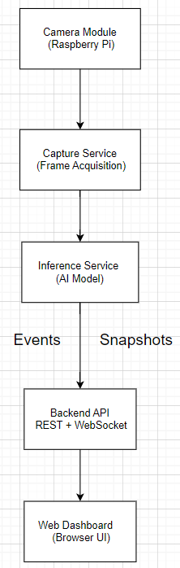
3. Component Diagram (Logical)
Main Components
- Capture Service
  - Controls camera
  - Captures frames at configurable FPS
  - Sends frames to inference queue
- Inference Service
  - Preprocesses frames
  - Runs AI model inference
  - Outputs defect type, confidence, timestamp
- Backend API
  - Session management
  - Alert generation
  - Data persistence
  - REST + WebSocket endpoints
- Storage Layer
  - SQLite database for metadata and events
  - File system for images/snapshots
- Web Dashboard
  - Live monitoring
  - Alerts visualization
  - History and reports

4. Technology Stack Selection (with Trade-offs)
Hardware
- Raspberry Pi 4 / 5
  - Low cost
  - Sufficient for lightweight inference
  - Widely supported
Backend
- Python
  - Strong ML ecosystem
  - Fast prototyping
- FastAPI
  - High performance
  - Native async + WebSocket support
AI / ML
- YOLO-based Object Detection
  - Proven real-time performance
  - Good trade-off between accuracy and speed
- TensorFlow Lite / ONNX Runtime
  - Optimized for edge devices
Frontend
- React
  - Lightweight and flexible
  - Strong real-time UI support
  - Easier dashboard prototyping compared to Angular

5. Integration and Communication Protocols
Communication | Protocol | Reason
Capture → Inference | In-memory queue | Low latency
Backend → Dashboard (events) | WebSocket | Real-time alerts
Dashboard → Backend | REST (HTTP) | Simplicity
Storage | SQLite + FS | Lightweight, local

6. UML – Class Diagram (Textual Description)
Main Classes
Frame
- id
- timestamp
- image_data
DetectionResult
- defect_type
- confidence
- timestamp
Session
- session_id
- start_time
- end_time
- status
Alert
- alert_id
- defect_type
- confidence
- image_path
- timestamp
User
- user_id
- username
- role

7. UML – Sequence Diagram (Detect Failure)
Flow:
- Capture Service captures frame
- Frame sent to Inference Service
- AI model processes frame
- DetectionResult generated
- Backend evaluates confidence
- Alert created (if threshold exceeded)
- WebSocket pushes alert to Dashboard

8. UML – Activity Diagram (Monitoring Session)
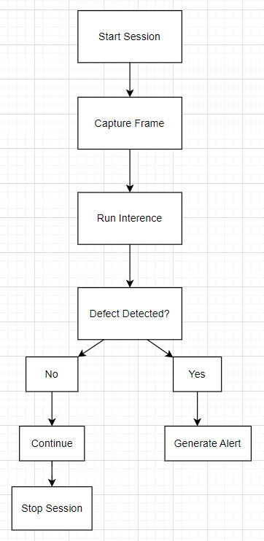
9. Database Schema Design
Tables
sessions
- session_id (PK)
- start_time
- end_time
- printer_name
- filament_type
detections
- detection_id (PK)
- session_id (FK)
- defect_type
- confidence
- timestamp
alerts
- alert_id (PK)
- detection_id (FK)
- image_path

10. API Specification (Core Endpoints)
REST API
Method | Endpoint | Description
POST | /session/start | Start monitoring
POST | /session/stop | Stop monitoring
GET | /sessions | List past sessions
GET | /alerts/{session_id} | Get alerts

WebSocket
- /ws/alerts – real-time alert streaming

11. Interface Design (Dashboard)
Main Views
- Live Monitoring Page
  - Camera feed
  - Status indicator (OK / Warning / Failure)
  - Latest alert
- History Page
  - Session list
  - Alert timeline
  - Snapshot preview

12. Design Patterns Used
Pattern | Usage
Producer–Consumer | Capture → Inference
Observer | Dashboard alert updates
MVC | Backend + UI separation
Singleton | Model loading

13. Pseudocode (Inference Loop)
while session_active:
frame = capture_frame()
result = model.infer(frame)
if result.confidence > threshold:
save_snapshot(frame)
create_alert(result)
notify_dashboard(result)

14. Modular Decomposition
Module | Responsibility
Capture | Image acquisition
Inference | AI processing
Backend | Business logic
Storage | Data persistence
UI | Visualization
- High cohesion: each module has one responsibility
- Low coupling: modules communicate via defined interfaces

15. Conway’s Law Consideration
The system architecture mirrors the project’s development structure: a small team working on clear functional boundaries (AI, backend, frontend). This alignment reduces communication overhead and integration complexity, consistent with Conway’s Law principles.

16. Summary
This detailed design defines a modular, real-time, edge-based AI system for detecting 3D printing failures. The architecture supports low latency, privacy preservation, extensibility, and aligns with current academic research and practical constraints. The design directly fulfills the functional and non-functional requirements defined in Lesson 5 and prepares the project for implementation and evaluation.

